STATE OF MAINE
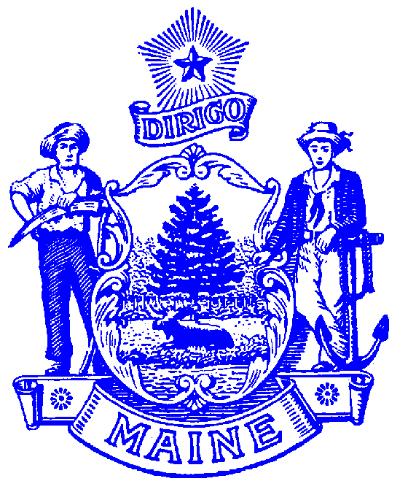
DEPARTMENT OF LABOR

Laura Fortman
COMMISSIONER

STATE WORKFORCE BOARD
55 STATE HOUSE STATION
AUGUSTA, MAINE 04333-0055
Janet T. Mills
GOVERNOR
www.Maine.gov/SWB

MAINE WORKFORCE DEVELOPMENT SYSTEM
Subject: | Local Chambers of Commerce, local economic development districts, industry partnerships, and entities that represent industry sectors | Policy No: | PY-23-
To: | - Bureau of Employment Services, Maine Department of Labor  - Local Workforce Development Boards | From: | Christopher Quint, Director, State Workforce Board
Issuance Date: | TBD | Status: | ACTIVE
Authority: | - 20 CFR 678.420  - 20 CFR 679.320
Key: | CEO = Chief Elected Official, LWDB = Local Board; PM = Program Memorandum; RP = Required Partner; SWB = State Workforce Board

Purpose
This policy rescinds and replaces a previous policy, PY 12-04 “Chambers of Commerce as required partner in local workforce areas”, which required Chambers of Commerce as a required partner on Local Workforce Development Boards. The new policy encourages Local Workforce Development Boards (LWDB’s) to confer with local Chambers of Commerce, local economic development districts, industry partnerships, and entities that represent industry sectors, such as trade associations., Chambers of Commerce are unable to fill required business member seats on LWDB’s because they do not meet the requirements under 20 CFR 679.320 which states a majority of the members must be representatives of business in the local area that provide employment opportunities in high-demand industry sectors or occupations.

Background
To increase collaboration and foster stronger partnerships between workforce development activities and economic development activities, this policy encourages LWDB’s to form relationships and confer with their local Chambers of Commerce, local economic development districts, industry partnerships, and entities that represent industry sectors, such as trade associations.

The State Workforce Board (SWB) has recognized Maine’s local Chambers of Commerce, local economic development districts, industry partnerships, and entities that represent industry sectors as vital resources for business input into the workforce development system. The above entities can convene local businesses and facilitate discussions that provide input to LWDB’s workforce needs in the local or regional business community.

Although individual employers who are members of the above entities can serve as members of LWDB’s, this policy seeks to recognize and encourage a specific relationship that provides deliberate business input to inform local workforce and economic development activities, programs, and services.

A deliberate relationship among LWDB’s and their local Chambers of Commerce, local economic development districts, industry partnerships, and entities that represent industry sectors will help provide additional information to both the LWDB’s and the SWB in addressing employment and training needs, with the goal of leveraging and maximizing workforce and economic development resources.

Policy
Local Workforce Development Boards are encouraged to confer, where appropriate, with local Chambers of Commerce, local economic development districts, industry partnerships, and entities that represent industry sectors within their areas to establish and maintain programs, services, and activities. These partnerships aim to establish and maintain programs, services and activities that engage employers in workforce development planning and connect them to workforce development services. Specifically, partnerships are to increase awareness of, and connection to, Maine’s CareerCenters with the intended outcome of increasing effective, business-led workforce and economic development activities. These activities include, but are not limited to, employment of individuals in high wage and high growth occupations and industry, and business-responsive job training programs.

Guidance
LWDB’s and local Chambers of Commerce, local economic development districts, industry partnerships, and entities that represent industry sectors are encouraged to be creative, innovative, experimental, and flexible. Below are some suggested activities for Chamber-LB activities:

Local Chambers, Local Economic Development Districts, Industry Partnerships, and entities that represent industry sectors could:
- Provide a monthly column on employment issues/services in their newsletters.
- Encourage members to list job vacancies with Maine Job Bank.
- Hold their meetings at CareerCenters.
- Co-host/co-sponsor events (job fairs, conferences, targeted events for specific industries or specific job seeking populations, business awards, roundtables, workshops, etc.).
- Invite LWDB and/or CareerCenter personnel to speak at Chamber meetings and events.
- Co-brand certain products or activities to leverage LWDB’s, CareerCenter’s, and local Chambers of Commerce, local economic development districts, industry partnerships, and entities that represent industry sectors reputation and public image (workshops, outreach materials, etc.).
- Provide website links to local Chambers of Commerce, local economic development districts, industry partnerships, and entities that represent industry sectors on websites of LWDB’s and the CareerCenter website.
- Co-author op-eds.
- Share mailing lists with CareerCenters.
- Co-support job training programs.
- Provide incentives to members who work with CareerCenters, list job vacancies with Job Bank, etc.
- Connect businesses with business services at CareerCenters.
- Assist workforce development partners with grant proposals.
- Partner on special projects to increase presence of older workers, people with disabilities, veterans, women, youth, and minority individuals in their members’ workforces.

LWDB’s and CareerCenters could:
- Host special programs for businesses that help increase local Chambers of Commerce, local economic development districts, industry partnerships, and entities that represent industry sectors membership while promoting CareerCenter services.
- Provide website links to CareerCenters, LWDB’s, other workforce development entities on websites of local Chambers of Commerce, local economic development districts, industry partnerships, and entities that represent industry sectors.
- Use the local Chambers of Commerce and local economic development districts as a mechanism to identify local industry partnerships and develop programs to meet local industry partnership needs.
- Use their connection to Chambers to perform outreach to businesses.
- Offer technical assistance programs to local Chambers of Commerce, local economic development districts, industry partnerships, and entities that represent industry sectors members on: OJTs, Apprenticeship, CSSP, foreign labor needs, SafetyWorks!, labor market information, posting job vacancies with the Job Bank, wage and hour law, child labor law, other labor law updates and reviews.
- Help businesses identify training providers for their workforces.
- Offer to write columns and articles for Chamber publications.
- Co-host/co-sponsor events (job fairs, conferences, targeted events for specific industries or specific job seeking populations, business awards, roundtables, workshops, etc.).
- Invite local Chambers of Commerce, local economic development districts, industry partnerships, and entities that represent industry sectors members to business-targeted/business only programs, events.
- Establish a business-oriented award and collaborate with local Chambers of Commerce, local economic development districts, industry partnerships, and entities that represent industry sectors on this.
- Partner on special projects to increase presence of older workers, people with disabilities, veterans, women, youth, and minority individuals in their members’ workforces.
- Facilitate connections among local Chambers of Commerce, local economic development districts, industry partnerships, and entities that represent industry sectors to programs and services that serve job seekers and workers, especially local community-based organizations and service providers.
- Membership in local Chambers of Commerce, local economic development districts, industry partnerships, and entities that represent industry sectors.

Direct Inquiries To:
Maine State Workforce Board
120 State House Station
45 Commerce Drive
Augusta Maine, 04333
swb.dol@maine.gov
Effective Date:

